8.57: Solving Eq. (8.40) for 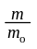, the fraction of the original rocket mass that is not fuel,
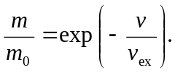
a) For
b)

